



NOVEMBER EXAMINATION

NATIONAL CERTIFICATE

# STRENGTH OF MATERIALS AND STRUCTURES N5

(8060065)

27 November 2014 (Y-Paper)



REQUIREMENTS: Hot rolled structural steel sections BOE8/2

Calculators may be usedn

This question paper consists of 4 pages and 2 diagram sheets.

-2- 

DEPARTMENT OF HIGHER EDUCATION AND TRAINING

REPUBLIC OF SOUTH AFRICA

NATIONAL CERTIFICATE

STRENGTH OF MATERIALS AND STRUCTURES N5

TIME: 3 HOURS MARKS: 100

INSTRUCTIONS AND INFORMATION Answer ALL the questions.

1. Read ALL the questions carefully.
2. Number the answers according to the numbering system used in this question paper.
3. Write neatly and legibly.

-3- 



When the tensile test was carried-out on a 46 mm round shaft with a length of 180 mm, the extension recorded was 0,074mm when a force of 165 kN was applied.

Assume the extension is within the elastic limit and calculate:

|  |  |
| --- | --- |
| 1 .1 the stress in the shaft | (3) |
| 1 .2 the strain in the shaft | (2) |
| 1 .3 Youngl s modulus of elasticity | (2) |

[7]

## QUESTION 2

A hollow shaft must transmit 1 350 kW at 170 rpm. The outside diameter must be 1,5 times the inside diameter. The maximum torque is 40% more than the mean torque.

Calculate:

2.1 the diameters of the hollow shaft if the allowable stress is 190 MPa. (8)

2.2 the diameter of the solid shaft, with the same applicable specifications if the allowable stress is 190 MPa. (3)

2.3 the percentage saving in weight if the hollow shaft is used (same length). (3)

the comparison of the angle of twist of the hollow shaft to that of the solid shaft over the same length if both are of the same material. (3)

## QUESTION 3

FIGURE 1 DIAGRAM SHEET 1 (attached) shows a horizontal beam AE, 14 m long and carries a uniformly distributed load of 3,8 kN/m over the full span and a point load of 4 kN at the left hand end A. The beam is simply supported at B, 2 m from A and at C on the right which is Xm for E. There is a point of inflexion at D the centre of the

beam.

Draw the shear force and bending moment diagrams for this beam. [20]

## QUESTION 4

Calculate the efficiency of a double riveted lap joint with a rivet diameter of 24 mm and a plate thickness of 10 mm. The stresses are as follows:

Jlear = 75 MPa; tensile = 80 MPa and compressive = 130 MPa.



## QUESTION 5

FIGURE 2 on the DIAGRAM SHEET 1 (attached) shows a compound bar consisting of a copper bar with a cross-sectional area of 650 mm2 and a steel pipe with a crosssectional area of 480 mm2. The copper bar fits into the steel pipe and their ends are rigidly fixed together so that they are of the same length all the time. The initial length of the compound bar is 830 mm.

210 GPa; Ec = 105 GPa; = 6/0C•acopper —6/0C.

Calculate:

5.1 the stresses in the copper and steel if the temperature of the compound bar is

raised by 60 oc. (6)

5.2 the resultant stresses induced due to the temperature rise as well as the

application of an axial tensile external load of 55 kN. (8)

5.3 the final length of the compound bar. (3)

[17]

QUESTION 6

Graphically determine the magnitude and nature of forces in each member of the

structure shown in FIGURE 3 DIAGRAM SHEET 2 (attached).

QUESTION 7

A strut I is 8,2 m long with a cross-section as shown in FIGURE 4 DIAGRAM SHEET 2

(attached).

Use Euler's formula and calculate the buckling load if:

7.1 the ends are ball-jointed (9)

7.2 the ends are pinned, restricting rotation about y-y axis (5)

[14]

TOTAL: 100

## (8060065) T1520 ( E ) ( N27 )T

「SHEET 1

4 kN

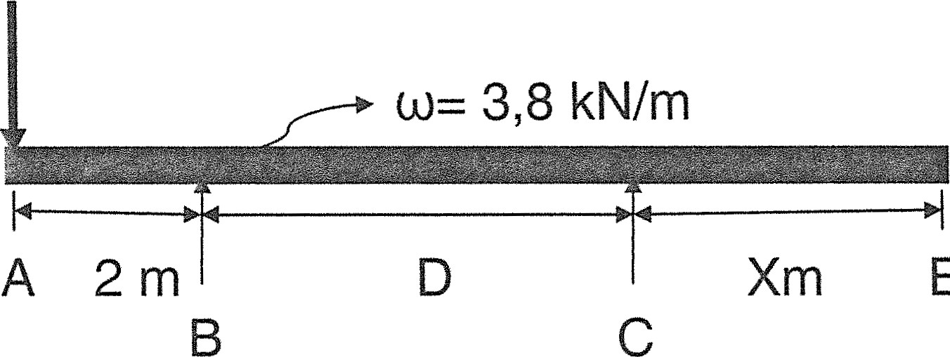

E

FIGURE 1

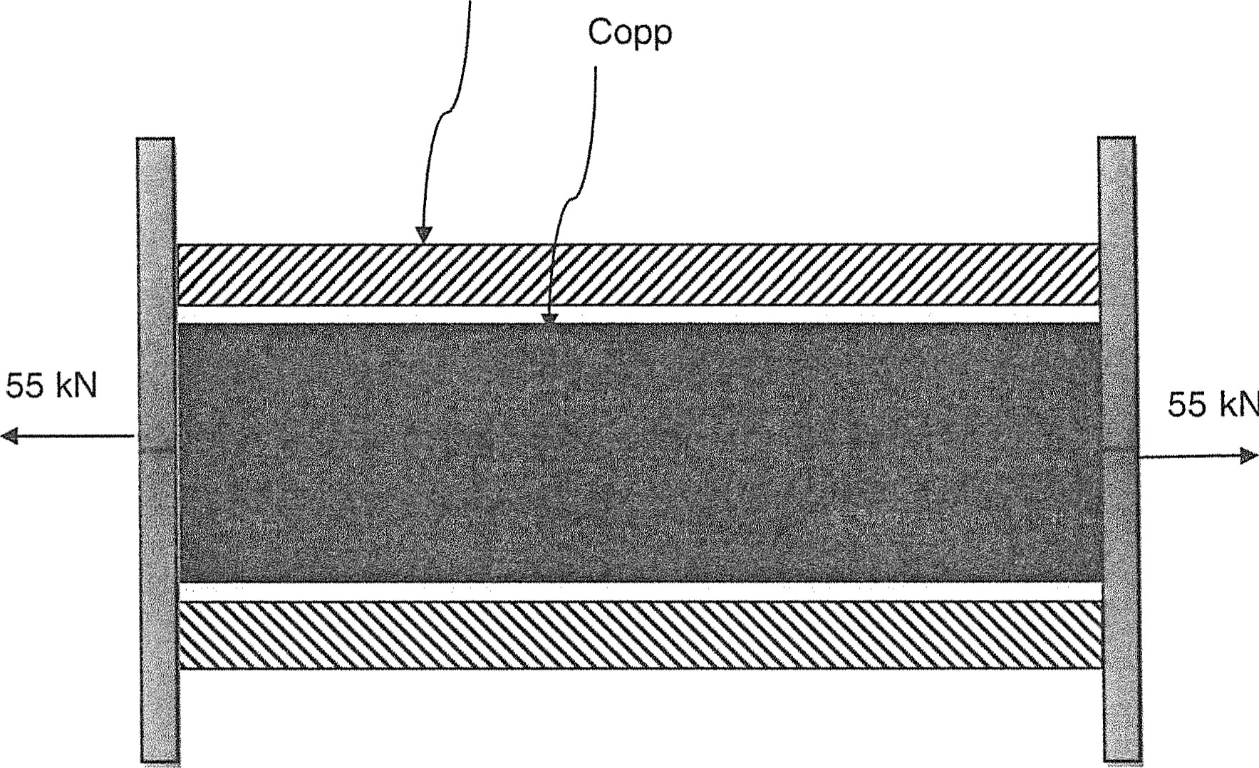

Steel

FIGURE 2

Please turn over

(8060065) -2- 

DIAGRAM SHEET 2

## 100 N 50 N

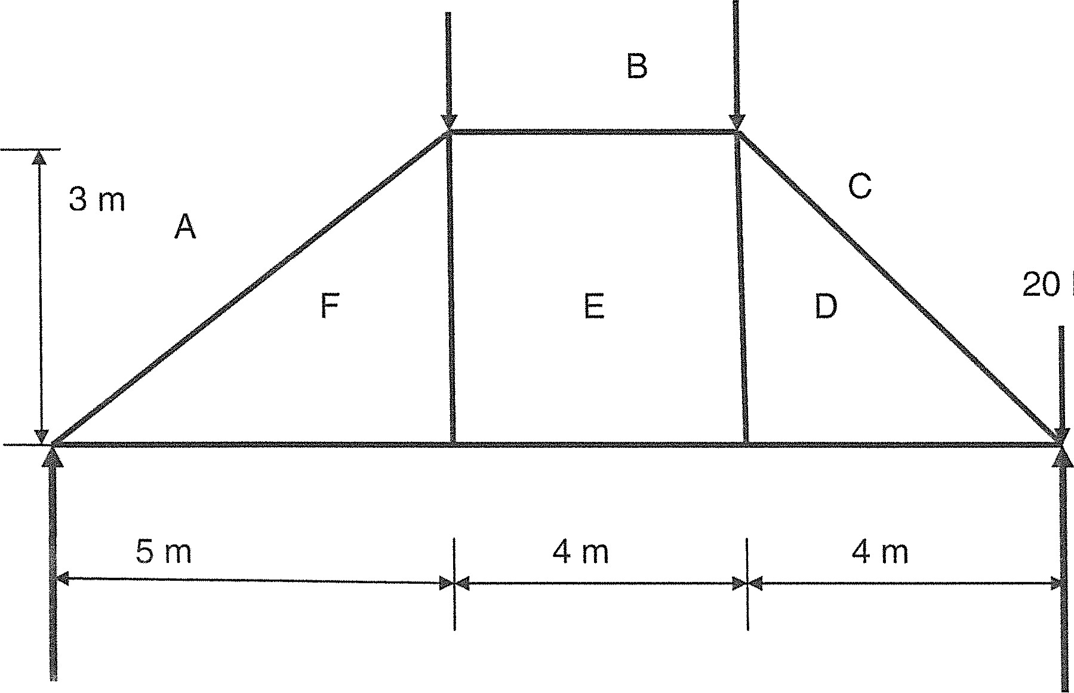

N

### FIGURE 3

|  |
| --- |
| 300 mm |
|  |

30 mm

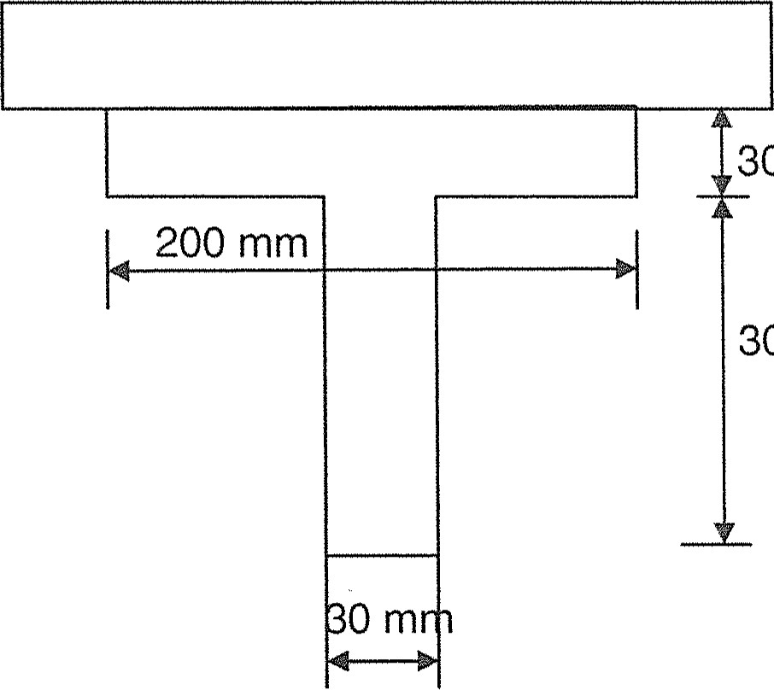30 mm

300 mm

### FIGURE 4